 [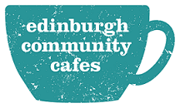](http://www.edinburghcommunitycafes.org.uk/)

**Booking form**

**Community Café Networking Event**  
**Thursday 11 June  
St Andrew’s and St George’s Church, George Street, Edinburgh**

**Please fill out the following form and email back to** [**anne.gibson5@nhs.net**](mailto:anne.gibson5@nhs.net) or **post to Anne Gibson, CFHS, NHS Health Scotland, Gyle Square, 1 South Gyle Crescent, Edinburgh, EH12 9EB, by Friday 29 May**

|  |  |
| --- | --- |
| Name |  |
| Job title |  |
| Organisation |  |
| Email address or contact phone number |  |
| Number of places wanted |  |
| If you have any access issues please detail |  |
| If you have any dietary requirements please detail |  |

**We may be able to assist with travel costs. If you would like assistance with travel costs, please contact Anne at the email address above or on 0131 314 5428.**

