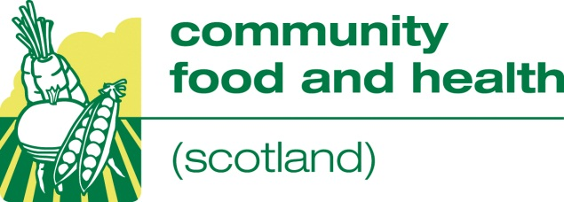
Thistle House, 2nd Floor, 91 Haymarket Terrace,
Edinburgh, EH10 5HE Tel: 0131 313 7500
Email: nhsHealthScotland-CFHS@nhs.net
www.communityfoodandhealth.org.uk

Evaluation Learning Exchanges
We are offering organisations the opportunity to book a place, for one of our Evaluation Learning Exchange days. Each day will have a similar format, reflecting together and sharing learning on various aspects of evaluation eg setting outcomes, collecting information and what to do with it. The day will include activities and opportunities to network with others. The Evaluation Learning Exchange days are:

- Thursday 13 February 2014, Glasgow (9.45 – 4.00)
- Wednesday 26 February 2014, Edinburgh (9.45 – 4.00)
- Wednesday 12 March 2014, Perth (9.45 – 4.00)
To book a place, tell us who want to take part, where they want to attend and if appropriate provide the additional information requested. The form should then be returned to Jacqui McDowell.

Organisation …………………………………………………………………………….
Name
Address
E-mail

The Evaluation Exchange I wish to attend is Glasgow Edinburgh Perth
(Please delete as appropriate)

Tell us about any special needs you have.

Please return the form to Jacqui McDowell at Jacqueline.McDowell@nhs.net or the address above, places will be reserved on a first come first served basis.

