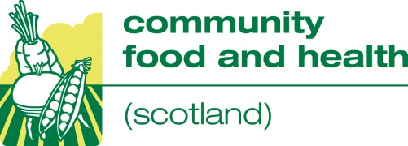

Introduction to Social Enterprise
7 November 2013
10 am – 1 pm
Re-union Canal Barge, 1 Union Path, Edinburgh
--------------------------------------------------------------------------------------------------------------------------------------
This one-day course is delivered by the Social Enterprise Academy and will look at:
- what is social enterprise?
- different models of social enterprise
- benefits and drawbacks of this business model.

Sixteen places are available. The closing date for applications is Thursday 24 October.
Applicants will be informed if they have a place by Friday 1 November.

This course is fully funded by CFHS.
--------------------------------------------------------------------------------------------------------------------------------------
Cancellation charge
We are committed to providing fully-funded training opportunities. The costs of delivering all of the courses in our learning and development programme (tutor, venue and catering costs) are being met by CFHS. If you book a place at one of our events and do not attend, CFHS reserves the right to impose a cancellation charge to cover some of the costs incurred. If implemented, we will charge you unless we have been notified that the place will not be used at least 10 days before the event and/or we are able to fill the place. This cancellation charge will be £50 or 50% of the cost to CFHS for providing this place, whichever is greater.
- - - - - - - - - - - - - - - - - - - - - - - - - - - - - - - - - - - - - - - - - - - - - - - - - - - - - - - - - - - - - - - - - - - - - - - - -
Application form – Introduction to social enterprise, 7 November
Your name
Click here to enter text.
Organisation
Click here to enter text.
Contact address
Click here to enter text.
Contact phone number Click here to enter text.
How many places to you want to book? Click here to enter text.
Names of people wanting to take part
Click here to enter text.
Click here to enter text.
Click here to enter text.
Click here to enter text.

Please let us know if you have any access or dietary requirements
Click here to enter text.

Please return your completed application to Anne Gibson, CFHS,
NHS Health Scotland, Thistle House, 2nd Floor, 91 Haymarket Terrace,
Edinburgh, EH12 5HE or email to anne.gibson5@nhs.net by Thursday 24 October.

